CURRICULUM VITAE


Bhoomi naik
Flat no -- 101 building 24 Street 13 discovery garden UAE
Contact Number +91-8146733870 , +91-8795110007
Email id : bhuminaik56@gmail.com

Area of Interest — F&B Service
EDUCATION:
Qualification/Degree | School/College | University or Board | Year
B. Sc. (H&HA) | Chitkara School of Hospitality, Rajpura, Punjab | NCHMCT NOIDA & IGNOU NEW DELHI | 2016-2019
Class XII | Tagore senior secondary  school,mayapuri,new Delhi | CBSE | 2015-2016
Class X | National institute of open schooling,newdelhi | CBSE | 2013-2014

TRAINING& PROJECTS:

Training:
17 weeks Industrial Training from Le Meridien, New Delhi(27 June 2017 —20 October 2017) Job Experience:
Currently Working in Five Palm Jumeriah Village as an F&B Hostess From 17 Feb, 2022 Worked in St.Regis Mumbai as an F&B Associate from July 1st, 2019 to 15 April, 2021
Worked at Seven Kitchens for 12 months
Worked at The Sahib Room & Kipling Bar for 6 months
Worked at By The Mekong for 2 months

Skills acquired:
Service
Bar knowledge
Tackle with the guest issues and complaints Up selling of our product
Cover Set up
Order taking from the guest Use of Micros
Billing & Settlement

Projects:
Served the esteemed guests who visited the University campus on various occasions Participated in valedictory function as a dance co-ordinater in the college Participated in hotel 4th anniversary function as a dance coordinator.

ACHIEVEMENTS:
Received certificate for participation in service and valedictory function Received appreciation for organizing the theme lunch in the college Received appreciation for participating in the cultural events of the college Received appreciation from the guest in guest voice.
Received appreciation from hotel to choreograph dance for Virtual Diwali occasion 2020.

PROFESSIONAL SKILLS:
Good Interpersonal Skills Team Player/Management Multi Tasker
Leadership Adaptable

INTEREST & HOBBIES:
Dancing Calligraphy Painting/ Drawing

PASSPORT DETAILS
Passport Number: T1806365
Date of Issue : 10/07/2019
Date of Expiry : 09/07/2029
Place of Issue : Lucknow

(BHOOMI NAIK)

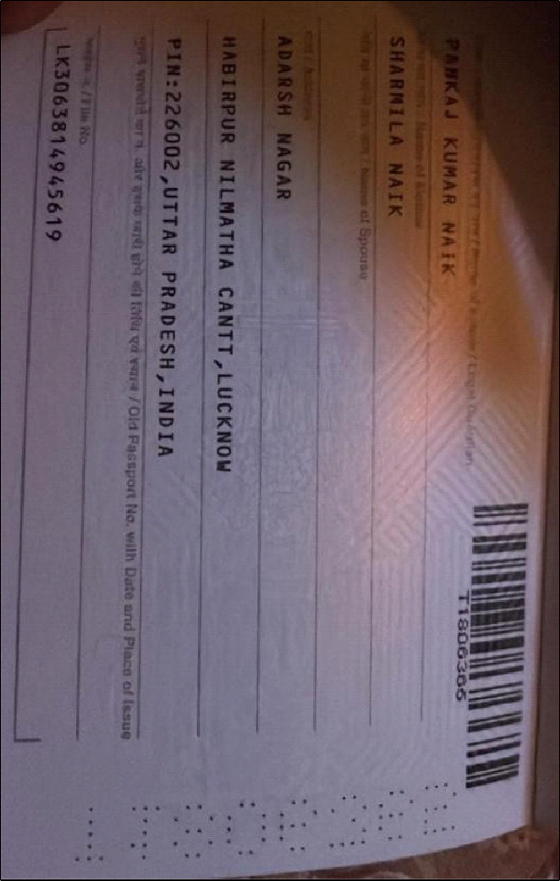

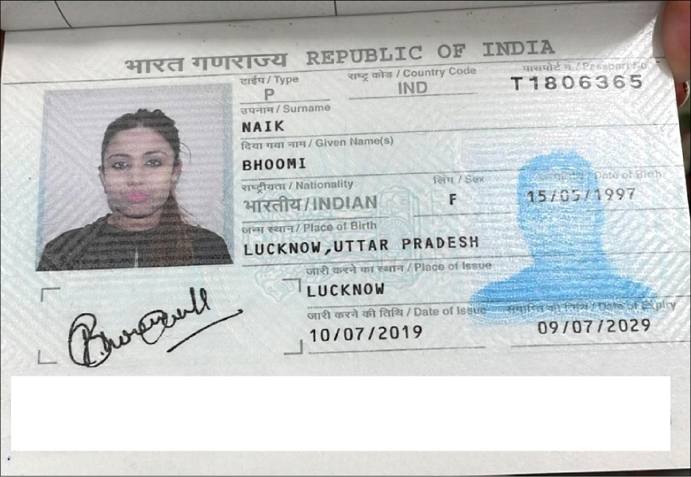

<znanAIK<<B*^ * ************* **** *** **
/ 1 $$§3 65<2 I N A 97O5 157 FZ 907 099'4'4*•‘¥ ******* * *

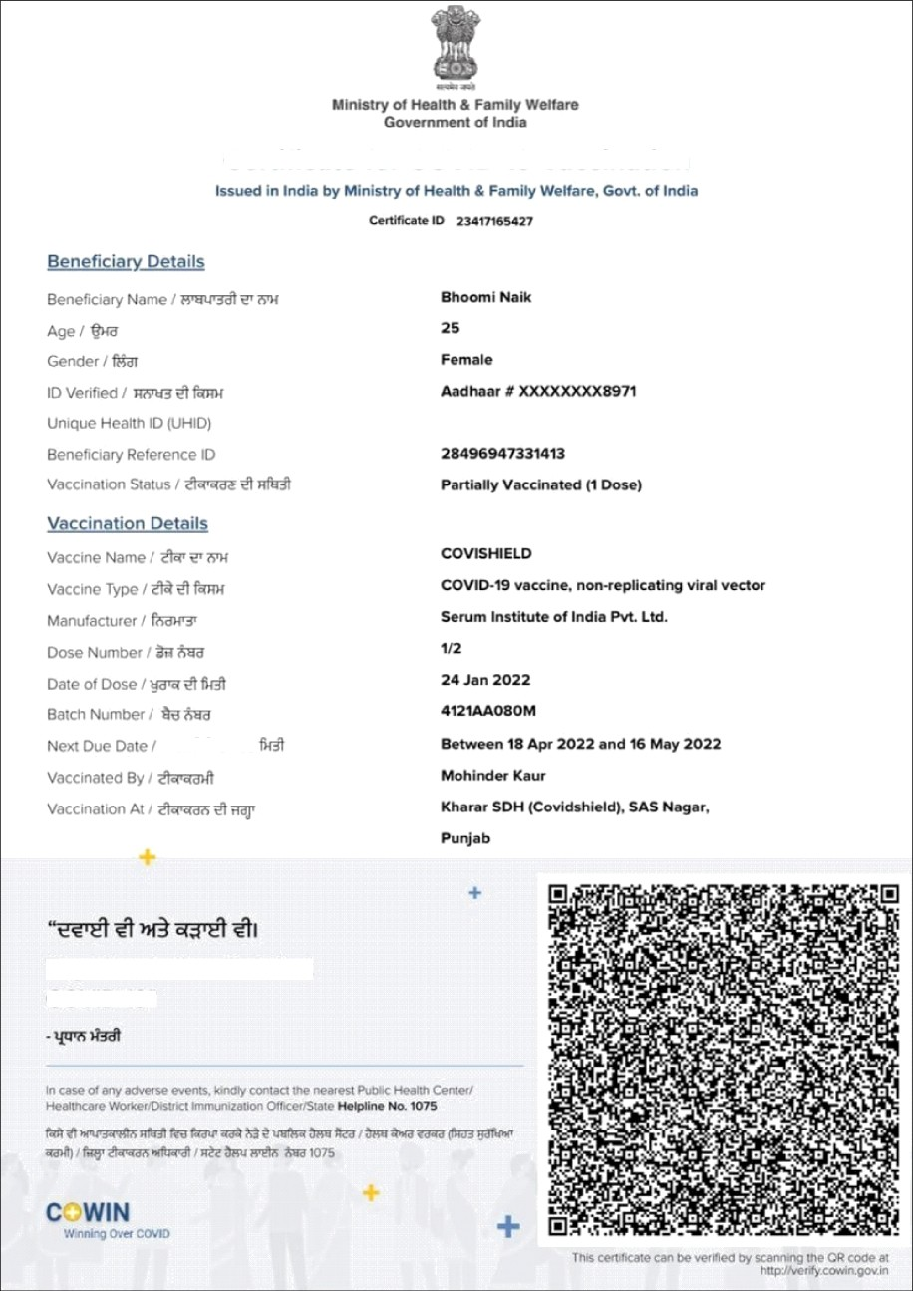

Certificate for COVID-19 Vaccination

Together, India will defeat COVID-19"

